**Superior University Reiwend Road**

Name: Haseeb Arshad

Roll no: SU92–BSSEM-F22-177

Section:5D

Subject: CN Lab  
Task 6

Submitted to: Sir Rasikh Ali

**Task 1:**

**Design network of "Lab-7" or “Lab-8” (2-3 rows of computers) Use: • Switch (1) • Router (1) • End-Devices like Laptop/PC Assign IP Address (167.158.15.0) using Command for Router. And Statically for End-Devices**

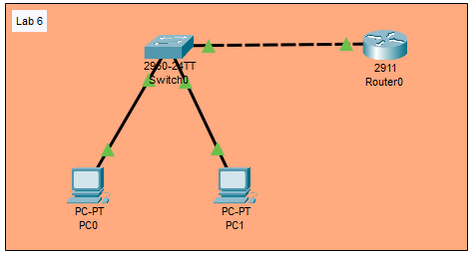

**Configure Router:**

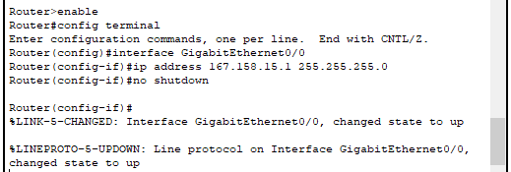

**Test Connectivity:**

